Was There a Trojan War? | Volume 57 Number 3, May/June 2004
by Manfred Korfmann

Despite assumptions to the contrary, archaeological work of the new Troy project has not been performed for the purpose of understanding Homer's Iliad or the Trojan War. For the past 16 years, more than 350 scholars, scientists, and technicians from nearly 20 countries have been collaborating on the excavations at the site in northwestern Turkey that began as an Early Bronze Age citadel in the third millennium B.C. and ended as a Byzantine settlement before being abandoned in A.D. 1350. However, as current director of the excavations, I am continually asked if Homer's Trojan War really happened. | 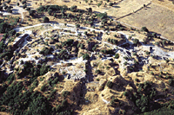  An aerial view of the site as it exists today (Troia Projekt) [LARGER IMAGE]
The Size of Troy
Troy appears to have been destroyed around 1180 B.C. (this date corresponds to the end of our excavation of levels Troy VIi or VIIa), probably by a war the city lost. There is evidence of a conflagration, some skeletons, and heaps of sling bullets. People who have successfully defended their city would have gathered their sling bullets and put them away for another event, but a victorious conqueror would have done nothing with them. But this does not mean that the conflict was the war--even though ancient tradition usually places it around this time. After a transitional period of a few decades, a new population from the eastern Balkans or the northwestern Black Sea region evidently settled in the ruins of what was probably a much weakened city.
The main argument against associating these ruins with the great city described in the Iliad has been that Troy in the Late Bronze Age was a wholly insignificant town and not a place worth fighting over. Our new excavations and the progress of research in southeastern Europe has changed such views regarding Troy considerably.
It appears that this city was, by the standards of this region at that time, very large indeed, and most certainly of supraregional importance in controlling access from the Mediterranean to the Black Sea and from Asia Minor to southeast Europe and vice versa. Its citadel was unparalleled in the wider region and, as far as hitherto known, unmatched anywhere in southeastern Europe. Troy was also evidently attacked repeatedly and had to defend itself again and again, as indicated by repairs undertaken to the citadel's fortifications and efforts to enlarge and strengthen them.
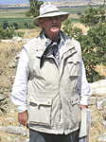 | German archaeologist Manfred Korfmann of the University of Tübingen has led the excavations at the site of Hisarllk/Troy in northwestern Turkey for the past 16 years. (Troia Projekt) [LARGER IMAGE]
A spectacular result of the new excavations has been the verification of the existence of a lower settlement from the seventeenth to the early twelfth centuries B.C. (Troy levels VI/VIIa) outside and south and east of the citadel. As magnetometer surveys and seven excavations undertaken since 1993 have shown, this lower city was surrounded at least in the thirteenth century by an impressive U-shaped fortification ditch, approximately eleven and a half feet wide and six and a half feet deep, hewn into the limestone bedrock. Conclusions about the existence and quality of buildings within the confines of the ditch have been drawn on the basis of several trial trenches and excavations, some of them covering a very large surface area. The layout of the city was confirmed by an intensive and systematic pottery survey in 2003. We have also discovered a cemetery outside the ditch to the south. The most recent excavations have determined that Troy, which now covers about seventy-five acres, is about fifteen times larger than previously thought.

The Setting of the Iliad
Homer took for granted that his audience knew a war had been fought for what was alternately called Ilios or Troy. The bard was mainly concerned with describing the wrath of Achilles and its consequences. He used Troy and the war as a poetic setting for a conflict between men and gods. From the archaeologist's point of view, however, the Iliad can be interpreted as a "setting" in an entirely different sense. One may see Homer or his informants as eyewitnesses to Troy and the landscape of Troy at the close of the eighth century B.C., the period when scholars generally agree Homer composed his epic.
Troy was largely a ruined site in Homer's day, but the remains of Troy VI/VIIa, both the citadel and the lower city, were still impressive. Contemporary audiences and later ones from the area around the city were supposed to be able to recognize the general outlines of places where the action happened from descriptive references in the Iliad. They could visualize it, for instance, whenever they climbed up a slope to a sanctuary in "holy Ilios." "Holy Ilios" is the most frequently repeated epithet in the Iliad, and one would expect to see a sacred building in such a place. We can make a convincing case for a sanctuary or sanctuaries, maybe in the form of a wooden building, from the early seventh century B.C. at the latest--roughly contemporary with Homer--on this site, which subsequently served as a cult center into the late Roman Empire. There is nothing in the archaeological record to contradict the assertion that Troy and the surrounding countryside formed the setting for Homer's Iliad in 700 B.C.
The Hittite Connection
Although Troy is in Anatolia, Carl Blegen, who directed excavations at the site in the 1930s, regarded Troy VI/VIIa as a Greek settlement. The idea of a Greek Troy, one that had also been entertained by Schliemann, became firmly established. These excavators had come from Greece to Troy, both literally and figuratively, and later returned to Greece, and were biased, most likely unconsciously, in their outlook. However, until the 1930s there was very little archaeologically within Anatolia that might have been compared with Troy, and certainly not in western Anatolia.
We know today, from our own excavations and even from earlier ones, that in all main respects, Bronze Age Troy had stronger ties with Anatolia than with the Aegean. We've learned this from the tons of local pottery and small finds, such as a seal with a local hieroglyphic inscription, as well as the overall settlement picture, mud-brick architecture, and cremation burials. Research by Anatolian specialists has shown that what we today call Troy was in the Late Bronze Age the kingdom of Wilusa, powerful enough to conclude treaties with the Hittite Empire; even the Egyptians seem to have been familiar with the city. Furthermore, according to Hittite records, there were political and military tensions around Troy precisely during the thirteenth and early twelfth centuries B.C.--the supposed time of Homer's Trojan War.
Was There A Trojan War?
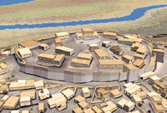 | Computer-modeling specialists have enabled the excavators of Troy to transform their raw data into a reconstruction of the citadel and lower city at the time of the Trojan War. (Troia Projekt) [LARGER IMAGE]
On the basis of my years of experience and knowledge of Troy, I feel the question ought to be: "Why should the scholars who won't rule out a possible degree of historicity in the basic events in the Iliad have to defend their position?" In light of the remarkable amount of discovery that has taken place over the last ten to fifteen years, the onus to defend positions should now be on those who believe there is absolutely no historical association between what happened at Late Bronze Age Troy and the events in the Iliad. On what basis, for instance, are claims made that Troy in the thirteenth and twelfth centuries B.C. was a third-class city, unworthy of foreign invasion and ultimately of Homer's attention? We expect that doubters will finally take note of the new archaeological facts of the case and the findings of a really interdisciplinary approach to Troy research.
According to the archaeological and historical findings of the past decade especially, it is now more likely than not that there were several armed conflicts in and around Troy at the end of the Late Bronze Age. At present we do not know whether all or some of these conflicts were distilled in later memory into the "Trojan War" or whether among them there was an especially memorable, single "Trojan War." However, everything currently suggests that Homer should be taken seriously, that his story of a military conflict between Greeks and the inhabitants of Troy is based on a memory of historical events--whatever these may have been. If someone came up to me at the excavation one day and expressed his or her belief that the Trojan War did indeed happen here, my response as an archaeologist working at Troy would be: Why not?
Evidence from Homer | "Was There a Trojan War?"  Volume 57 Number 3, May/June 2004
by Joachim Latacz
Recent Homeric scholarship has shown that the Iliad is the culmination of a protracted oral transmission of past events, transmitted by epic poetry improvised and performed by singers. Comparative historical linguistics has shown that the poetic medium in which the Iliad was passed on through the ages, the hexameter, in all probability was in use in Greece at the latest by the fifteenth century B.C., so that kernels of information transmitted via hexametric formulas from that time on could have been conveyed in Greek epic poetry. Here are a few examples of critical information transmitted in the Iliad from the Late Bronze Age to the period of Homer in the eighth century B.C.:
- The city called "Ilios" that sustained the attack in the Iliad must still have been known as "Wilios" in Bronze Age Greece. The sound /w/, spoken and written in Greek until at least 1200 B.C., was increasingly slurred in the dialect that Homer used around 450 years later until it was finally left off altogether. Consequently, the "Ilios" of the Iliad must have been the "Wilios" of the Late Bronze Age and in this way identical with "Wilusa," as Troy was known by the Hittite rulers of Anatolia at that time and in all probability by its inhabitants themselves.
- The Greek aggressors who attack Troy in the Iliad are called consistently "Achaiói" (which was in the Late Bronze Age "Achaiwói") or "Danaói," but at the time the Iliad was composed in the eighth century B.C., there were no such names for the Greek people. The "Achaiwói" of the Iliad must, therefore, be identical with the inhabitants of Ahhiyawa, a western kingdom implicated in Hittite documents of the fourteenth and thirteenth centuries B.C. in attacks on the western Anatolian coast. (The "Danaói" of the Iliad, on the other hand, must be identical with the inhabitants of "Danaya," a northern kingdom described in Egyptian documents of the fourteenth century B.C.)
From this, Homeric scholars can conclude that remnants of the memory of, among other things, one or several acts of aggression against the western Anatolian coast could have been transported via the hexameters of Ahhiyawan poetry down through the centuries between about 1200 and 800 B.C. Furthermore, Homer's Iliad has in all probability preserved remnants of the memory of one or more acts of aggression perpetrated by the Ahhiyawans against Wilusa in the thirteenth century B.C.
So did a "Trojan War" take place? Even with qualifications and certain reservations, I can give a basically positive answer. We still cannot prove that the Trojan War took place. However, all circumstantial evidence points to armed conflicts around 1200 B.C. between the area we now call Greece and the area that was called Wilusa at the time of the Hittite kingdom. The historical event or events left a mark in Greek poetry of that time, and because of the distinctive nature of the orally improvised Greek epic poetry of the Dark Ages, traces of this were preserved down to the time of Homer.
Joachim Latacz is professor of Greek philology at the University of Basel in Switzerland.
Evidence from Hittite Records | "Was There a Trojan War?"  Volume 57 Number 3, May/June 2004
by J.D. Hawkins
The Hittites were a powerful civilization that controlled most of Anatolia in the second millennium B.C. Their language, written in cuneiform script on clay tablets, was recovered and deciphered in the first decades of the twentieth century, but scholars are still wrestling with the problem of placing the cities and countries named in their ancient texts onto modern maps. The kingdom of Arzawa, located roughly in western Anatolia, was a threat to the Hittites throughout most of the fourteenth century B.C. but toward the end of that period was decisively defeated and broken up into provinces. The treaties concluded with the vassal rulers of these provinces are known among the Hittite texts.
Recent inscription readings have allowed scholars to locate the two main Arzawa lands in the central-west part of Turkey, extending from the inland plateau to the coast. The recent recognition that another kingdom, which the Hittites referred to as the Lukka lands, occupied what is now southwest Turkey thus leaves only northwest Anatolia as yet-to-be-filled space on the Hittite map.
One Arzawa land, Wilusa, is known principally from the treaty between its ruler Alaksandu and the Hittite king Mutawalli II (who ruled circa 1295-1272 B.C.). Sparse references in other texts of the fourteenth and thirteenth centuries B.C. imply that Wilusa was the remotest Arzawa land and lay on the coast, and this may be combined with that rare item, a Late Bronze Age city in northwestern Turkey. The evidence of its citadel and lower city is sufficient to suggest the seat of a local ruler of the period; and while the textual evidence points to Wilusa as a land, it would be usual for its capital city to have the same name.
A long letter from a Hittite king, probably Hattusili III (who ruled circa 1267-1237 B.C.), to the king of Ahhiyawa mentions that Wilusa was once a bone of contention between the two. The location of Ahhiyawa has been controversial since its earliest recognition in the Hittite texts in the 1920s. The scattered references to it suggested that it lay across the sea and that its interests often conflicted with those of the Hittites. What is now known of the geography of western Anatolia makes it clear that there could be no room on the mainland for the kingdom of Ahhiyawa. Furthermore, the references to the political interests of Ahhiyawa on the west coast mesh well with increasing archaeological evidence for Mycenaean Greeks in the area, so that it is now widely accepted that "Ahhiyawa" is indeed the Hittite designation for this culture.
From what we now can understand from the Hittite sources, the Arzawa land Wilusa, identified with the archaeological site of Troy, was a point of conflict between the Hittites and the Ahhiyawa. This provides a striking background for Homeric scholars researching the origin of the tradition of the Achaean attack on Ilios. There is every likelihood that the Iliad and the traditions of the Trojan War, however immortalized in epic narrative, do indeed preserve a memory of actual events of the Late Bronze Age.
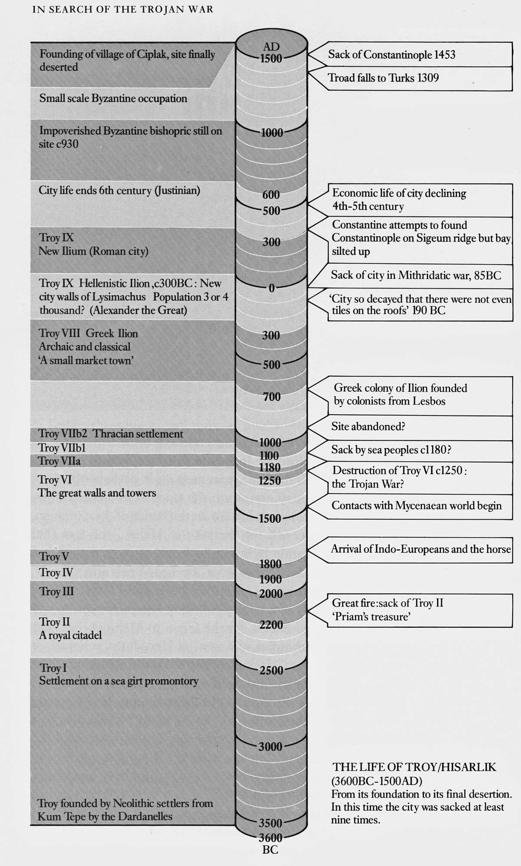
J.D. Hawkins is professor of ancient Anatolian languages at the School of Oriental and African Studies, University of London.
QUESTIONS:
- What is the evidence that the Trojan War stories could be based on actual historical events? Explain, be specific.
- What does the research about the Trojan War tell us about the nature of ancient history?

